Operating Systems
BSCS [5-A]

FINAL TERM PROJECT REPORT



Submitted By:

- Taiba Abid Jahangir

Submitted to: Mr. Rizwan Khalid

PROJECT NAME

CPU Scheduling Simulator

1. PROJECT OVERVIEW
The CPU Scheduling Simulator is a Java-based desktop application designed to demonstrate how an Operating System manages multiple processes. The project provides a real-time visual representation of various scheduling algorithms, allowing for a better understanding of process management, turnaround time, and waiting time calculation.

2. PROJECT STRUCTURE
The project is organized in a clean, professional hierarchy to ensure modularity and ease of use:
- Root Folder: Contains the README.md for general documentation.
- src/com/simulator/: Contains the source code files.
  - MainDashboard.java: The core engine that handles the GUI and scheduling logic.
  - Process.java: The data model representing an individual process with attributes like ID, Burst Time, and Priority.
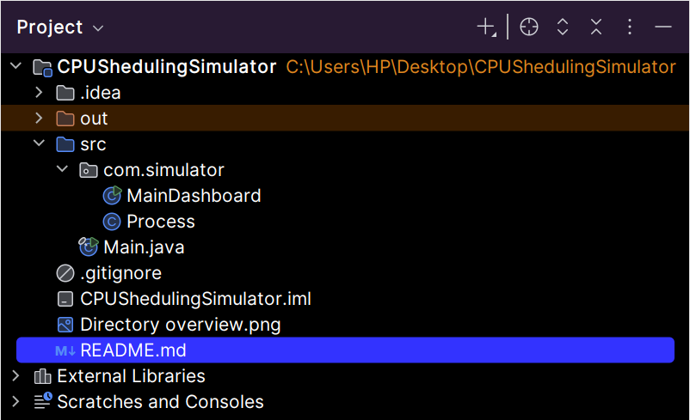
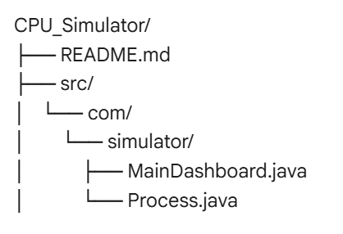

3. IMPLEMENTED ALGORITHMS
The simulator supports four fundamental scheduling strategies:
- First Come First Serve (FCFS): Processes are executed in the exact order they arrive in the queue.
- Shortest Job First (SJF): The system picks the process with the smallest Burst Time (BT) to run next.
- Priority Scheduling: Processes are sorted based on their priority level (lower numerical values represent higher priority).
- Round Robin (RR): A preemptive algorithm where each process gets a fixed "Time Quantum" (2 ticks) before being moved back to the queue.

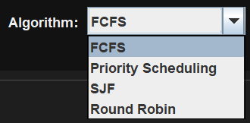

4. SYSTEM FEATURES
- Real-Time Gantt Chart: A visual history of which process occupied the CPU at any given time.
- Manual Entry: Users can generate processes on-the-fly with randomized data.
- Dynamic Countdown: The "Rem" (Remaining Time) indicator shows a live countdown of the work left for the active process.
- Reset Functionality: Allows the user to clear all current data and simulations to perform a fresh comparative analysis.

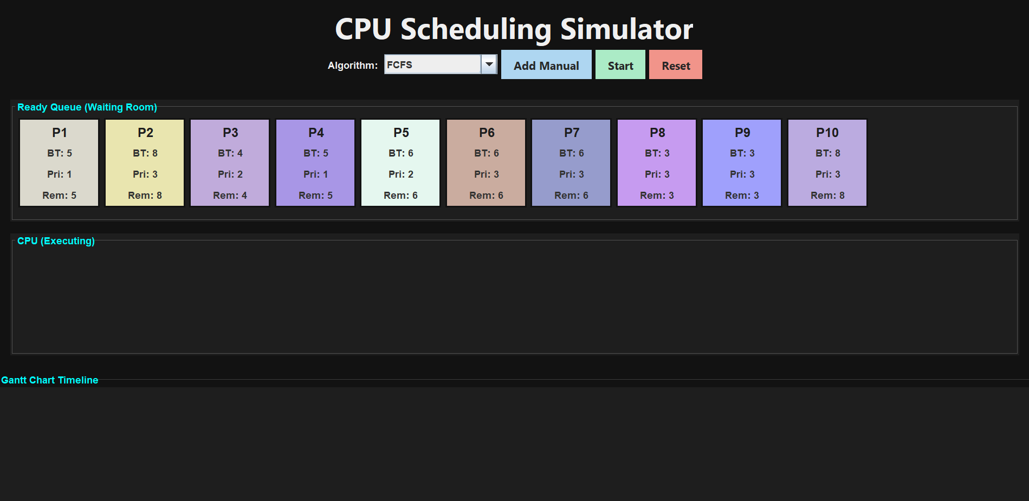
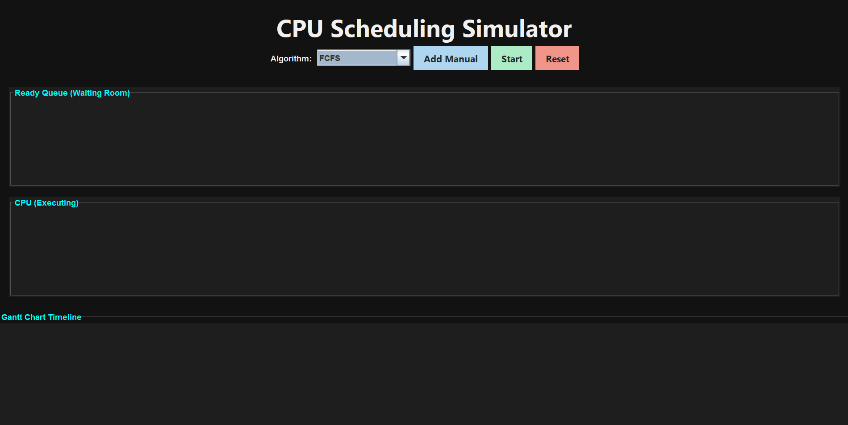

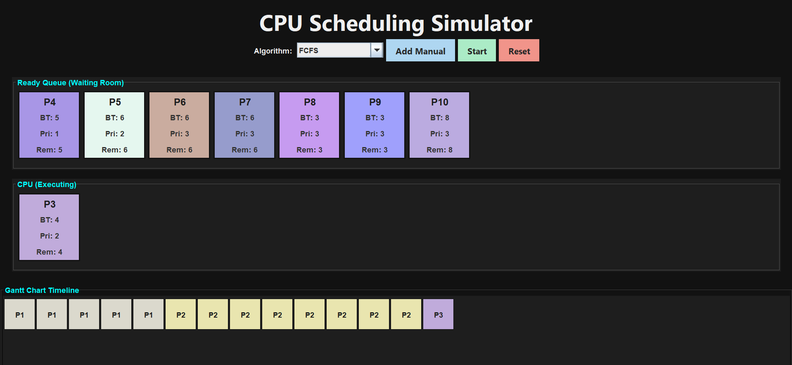

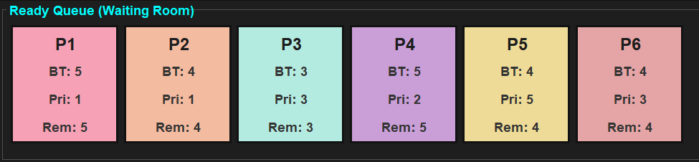

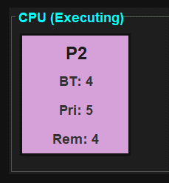

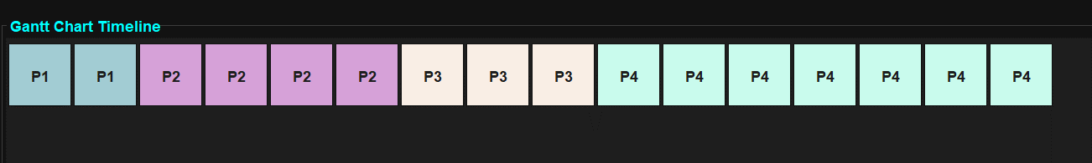

5. PERFORMANCE METRICS
Upon completion of a simulation, the tool automatically displays a Results Table calculating:
- Finish Time: The exact time a process completed execution.
- Turnaround Time (TAT): Total time from arrival to completion (Finish Time - Arrival Time).
- Waiting Time (WT): Time the process spent waiting in the queue (Turnaround Time - Burst Time).
- Average Waiting Time: The sum of all waiting times divided by the total number of processes.
